**Estructura del Proyecto**

1. **Ms-doctores**

**Estructura de Paquetes:**

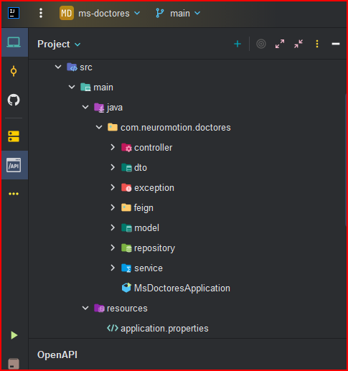

**Application.properties**

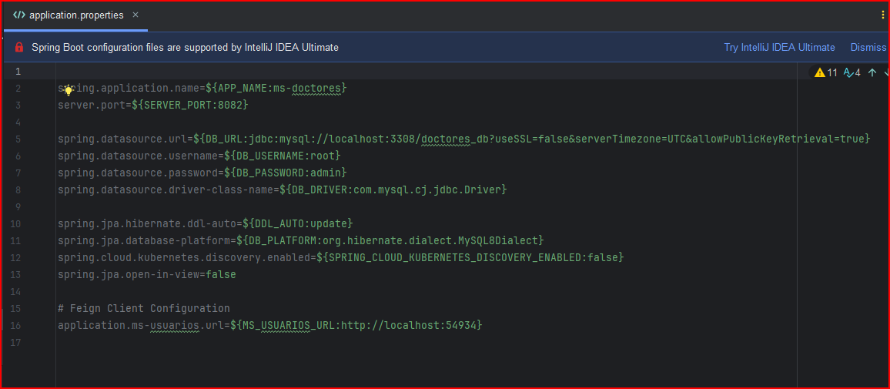

**Pom.xml**

|  |
| --- |
| <?xml version="1.0" encoding="UTF-8"?> <project xmlns="http://maven.apache.org/POM/4.0.0" xmlns:xsi="http://www.w3.org/2001/XMLSchema-instance"  xsi:schemaLocation="http://maven.apache.org/POM/4.0.0 https://maven.apache.org/xsd/maven-4.0.0.xsd">  <modelVersion>4.0.0</modelVersion>  <parent>  <groupId>org.springframework.boot</groupId>  <artifactId>spring-boot-starter-parent</artifactId>  <version>3.4.4</version>  <relativePath/> <!-- lookup parent from repository -->  </parent>  <groupId>com.neuromotion</groupId>  <artifactId>ms-doctores</artifactId>  <version>0.0.1-SNAPSHOT</version>  <name>ms-doctores</name>  <description>Demo project for Spring Boot</description>  <url/>  <licenses>  <license/>  </licenses>  <developers>  <developer/>  </developers>  <scm>  <connection/>  <developerConnection/>  <tag/>  <url/>  </scm>  <properties>  <java.version>17</java.version>  <spring-cloud.version>2024.0.1</spring-cloud.version>  </properties>  <dependencies>  <dependency>  <groupId>org.springframework.boot</groupId>  <artifactId>spring-boot-starter-actuator</artifactId>  </dependency>  <dependency>  <groupId>org.springframework.cloud</groupId>  <artifactId>spring-cloud-starter-kubernetes-discoveryclient</artifactId>  </dependency>  <dependency>  <groupId>org.springframework.boot</groupId>  <artifactId>spring-boot-starter-data-jpa</artifactId>  </dependency>  <dependency>  <groupId>org.springframework.boot</groupId>  <artifactId>spring-boot-starter-web</artifactId>  </dependency>  <dependency>  <groupId>org.springframework.cloud</groupId>  <artifactId>spring-cloud-starter-openfeign</artifactId>  </dependency>   <dependency>  <groupId>com.h2database</groupId>  <artifactId>h2</artifactId>  <scope>runtime</scope>  </dependency>  <dependency>  <groupId>com.mysql</groupId>  <artifactId>mysql-connector-j</artifactId>  <scope>runtime</scope>  </dependency>  <dependency>  <groupId>org.springframework.boot</groupId>  <artifactId>spring-boot-starter-test</artifactId>  <scope>test</scope>  </dependency>  <dependency>  <groupId>org.projectlombok</groupId>  <artifactId>lombok</artifactId>  <scope>provided</scope>  </dependency>  <dependency>  <groupId>jakarta.validation</groupId>  <artifactId>jakarta.validation-api</artifactId>  <version>3.0.2</version>  </dependency>  <dependency>  <groupId>org.hibernate.validator</groupId>  <artifactId>hibernate-validator</artifactId>  <version>8.0.1.Final</version>  </dependency>  <dependency>  <groupId>org.springdoc</groupId>  <artifactId>springdoc-openapi-starter-webmvc-ui</artifactId>  <version>2.5.0</version>  </dependency>  </dependencies>  <dependencyManagement>  <dependencies>  <dependency>  <groupId>org.springframework.cloud</groupId>  <artifactId>spring-cloud-dependencies</artifactId>  <version>${spring-cloud.version}</version>  <type>pom</type>  <scope>import</scope>  </dependency>  </dependencies>  </dependencyManagement>   <build>  <plugins>  <plugin>  <groupId>org.springframework.boot</groupId>  <artifactId>spring-boot-maven-plugin</artifactId>  </plugin>  </plugins>  </build>  </project> |

1. **Ms-usuarios**

**Estructura de Paquetes**

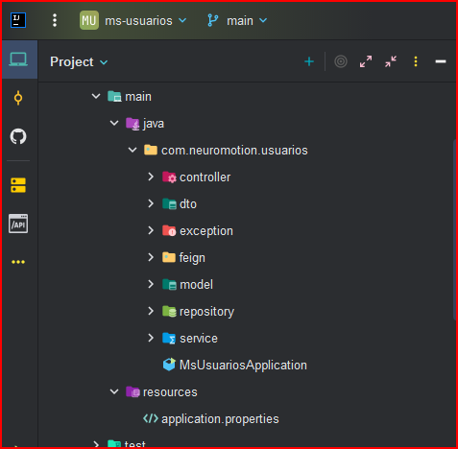

**Application.properties**

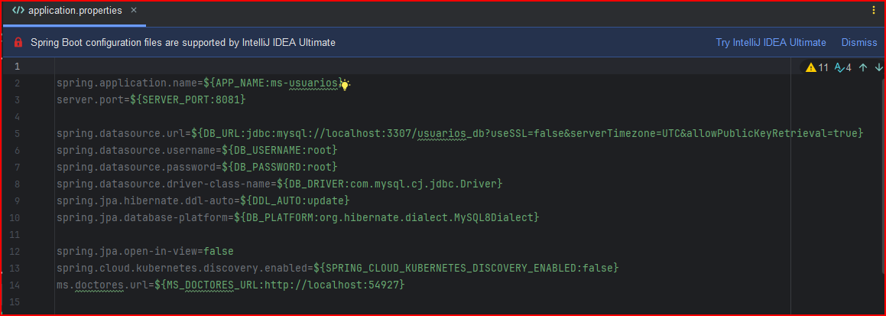

**Pom.xml**

|  |
| --- |
| <?xml version="1.0" encoding="UTF-8"?> <project xmlns="http://maven.apache.org/POM/4.0.0" xmlns:xsi="http://www.w3.org/2001/XMLSchema-instance"  xsi:schemaLocation="http://maven.apache.org/POM/4.0.0 https://maven.apache.org/xsd/maven-4.0.0.xsd">  <modelVersion>4.0.0</modelVersion>  <parent>  <groupId>org.springframework.boot</groupId>  <artifactId>spring-boot-starter-parent</artifactId>  <version>3.4.4</version>  <relativePath/> <!-- lookup parent from repository -->  </parent>  <groupId>com.neuromotion</groupId>  <artifactId>ms-usuarios</artifactId>  <version>0.0.1-SNAPSHOT</version>  <name>ms-usuarios</name>  <description>Demo project for Spring Boot</description>  <url/>  <licenses>  <license/>  </licenses>  <developers>  <developer/>  </developers>  <scm>  <connection/>  <developerConnection/>  <tag/>  <url/>  </scm>  <properties>  <java.version>17</java.version>  <spring-cloud.version>2024.0.1</spring-cloud.version>  </properties>  <dependencies>  <dependency>  <groupId>org.springframework.boot</groupId>  <artifactId>spring-boot-starter-actuator</artifactId>  </dependency>  <dependency>  <groupId>org.springframework.boot</groupId>  <artifactId>spring-boot-starter-data-jpa</artifactId>  </dependency>  <dependency>  <groupId>org.springframework.boot</groupId>  <artifactId>spring-boot-starter-web</artifactId>  </dependency>   <dependency>  <groupId>com.h2database</groupId>  <artifactId>h2</artifactId>  <scope>runtime</scope>  </dependency>  <dependency>  <groupId>com.mysql</groupId>  <artifactId>mysql-connector-j</artifactId>  <scope>runtime</scope>  </dependency>  <dependency>  <groupId>org.springframework.boot</groupId>  <artifactId>spring-boot-starter-test</artifactId>  <scope>test</scope>  </dependency>  <dependency>  <groupId>org.projectlombok</groupId>  <artifactId>lombok</artifactId>  <scope>provided</scope>  </dependency>  <dependency>  <groupId>jakarta.validation</groupId>  <artifactId>jakarta.validation-api</artifactId>  <version>3.0.2</version>  </dependency>  <dependency>  <groupId>org.hibernate.validator</groupId>  <artifactId>hibernate-validator</artifactId>  <version>8.0.1.Final</version>  </dependency>  <dependency>  <groupId>org.springframework.cloud</groupId>  <artifactId>spring-cloud-starter-kubernetes-discoveryclient</artifactId>  </dependency>  <dependency>  <groupId>org.springframework.cloud</groupId>  <artifactId>spring-cloud-starter-openfeign</artifactId>  </dependency>  <dependency>  <groupId>org.springdoc</groupId>  <artifactId>springdoc-openapi-starter-webmvc-ui</artifactId>  <version>2.8.9</version>  </dependency>  </dependencies>   <dependencyManagement>  <dependencies>  <dependency>  <groupId>org.springframework.cloud</groupId>  <artifactId>spring-cloud-dependencies</artifactId>  <version>${spring-cloud.version}</version>  <type>pom</type>  <scope>import</scope>  </dependency>  </dependencies>  </dependencyManagement>   <build>  <plugins>  <plugin>  <groupId>org.springframework.boot</groupId>  <artifactId>spring-boot-maven-plugin</artifactId>  </plugin>  </plugins>  </build>  </project> |

1. **Neuromotion Frontend**

